Chapter test

Chapter 1 Atoms and elements

Name:

Class:

Time permitted: 30 minutes

|  |  |  |  |  |
| --- | --- | --- | --- | --- |
|  | Section | Number of questions | Marks available | Marks achieved |
| A | Multiple choice | 15 | 15 |  |
| B | Short answer | 5 | 15 |  |
|  | Total |  | 30 |  |

Grade:

Scale:

|  |  |  |  |  |  |  |  |  |  |  |  |  |  |
| --- | --- | --- | --- | --- | --- | --- | --- | --- | --- | --- | --- | --- | --- |
| A+ | 29–30 | A | 26–28 | B | 23–25 | C | 19–22 | D | 15–18 | E | 9–14 | UG | 0–8 |

Comments:

Section A Multiple choice (15 marks)

Section A consists of 15 questions, each worth one mark. Each question has only one correct answer. Circle the correct answer. Attempt all questions. Marks will not be deducted for incorrect answers. You are advised to spend no more than 15 minutes on this section.

1 Which subatomic particle contributes mass but no charge to the atom?

A Proton

B Neutron

C Electron

D Nucleon

2 The current model of the atom was initially theorised by which scientist?

A Rutherford

B Dalton

C Democritus

D Bohr

3 The atomic number of zinc is:

A 65.

B 30.

C 91.

D 40.

For questions 4–6 refer to the table below, which shows the electron configuration of six atoms, labelled I–VI.

|  |  |  |  |  |  |  |
| --- | --- | --- | --- | --- | --- | --- |
| Atom | I | II | III | IV | V | VI |
| Electron configuration | 2, 1 | 2, 8, 7 | 2, 8, 8, 2 | 2, 8 | 2, 3 | 2, 8, 1 |

4 Which atom/s are from the same period of the periodic table?

A I, II, III

B I and IV

C II, III, VI

D I, IV, V

5 Which atom is an inert gas?

A I

B II

C III

D IV

6 Which atom has five protons?

A I

B III

C V

D VI

7 The diagram below shows an atom of beryllium. What is the name of the structure labelled X?

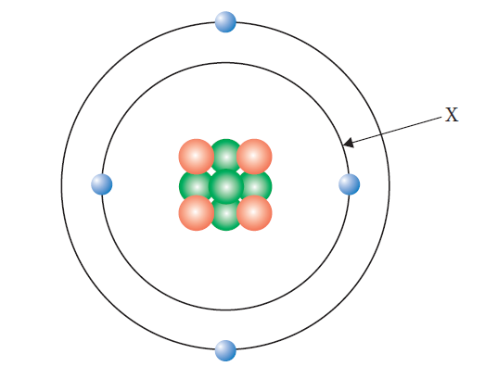

A Valence electron

B Nucleus

C Electron shell

D Electron

8 Why is the relative atomic mass on the periodic table a decimal?

A It is the average of the abundance and mass of all of the isotopes of the element.

B It is the average of the abundance and mass of all of the allotropes of the element.

C It depends on the percentage abundance of the element in the Earth’s crust.

D It depends on which atom of carbon the element is being compared to.

9 The order of subshells in terms of their energy is:

A 1s<2s<3s<4s<2p<3p<4p.

B 1s<2s<2p<3s<3p<3d<4s<4p.

C 1s<2s<2p<3s<3p<4s<3d<4p.

D 1s<2s<3s<3p<4s<4p.

10 Which of the elements below has the largest atomic radius?

A Potassium

B Calcium

C Bromine

D Krypton

11 Which of these elements has the lowest ionisation energy?

A Fluorine

B Chlorine

C Bromine

D Iodine

12 Acceleration of ions through an electric field occurs in:

A mass spectrometry.

B emission spectroscopy.

C atomic absorption spectroscopy.

D flame test.

13 Which of the following elements react with water in similar ways?

A Na and Al

B Na and K

C Mg and P

D Li and Br

14 If two electrons were removed from a neutral atom with the electron configuration 2, 8, 2 the new species would then have the same number of protons as:

A Ne.

B Mg.

C F.

D Na.

15 Which of the following is a semi-metal?

A Be

B B

C P

D Mg

Section B Short answer (15 marks)

Section B consists of five questions. Write your answers in the spaces provided. You are advised to spend 20 minutes on this section.

1 Oxygen has three isotopes, oxygen-16, oxygen-17 and oxygen-18. Their relative abundances are 99.76%, 0.04% and 0.20% respectively.

a Define the term isotope. (1 mark)

b Calculate the relative atomic mass of oxygen. (2 marks)

2 Complete the following table.

|  |  |  |  |  |  |
| --- | --- | --- | --- | --- | --- |
| Element | Atomic number | Mass number | Number of protons | Number of neutrons | Number of electrons |
| beryllium | 4 | 9 |  |  |  |
| selenium |  |  |  | 45 | 34 |

(3 marks)

3 Explain why ionisation energy and atomic radius show opposite trends for the first 20 elements. (3 marks)

4 The properties of three elements, X, Y and Z, are shown below.

|  |  |  |  |
| --- | --- | --- | --- |
| Element/property | Boiling point | Melting point | Electrical conductivity (solid) |
| X | –152 | –157 | n/a |
| Y | 609 | 419 | high |
| Z | 892 | 98 | high |

a Compare the state at room temperature for elements X and Y. (2 marks)

b Describe where element Z would be found on the periodic table. Give a reason for your answer. (1 mark)

5 Using the diagram below, describe the process of atomic absorption spectroscopy. (3 marks)

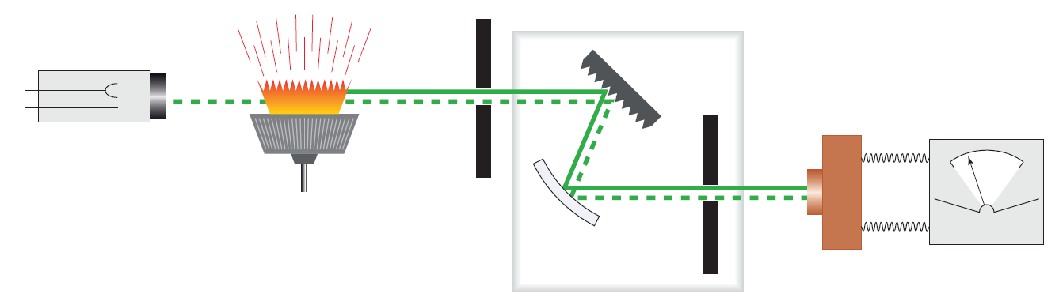

End of test (30 marks)